K_NEAREST_NEIGHBOURS:

**FOR ZOO.csv dataset:**

**Implement a KNN model to classify the animals in to categorie**

**Coding:**

# -*- coding: utf-8 -*-

"""

Created on Wed Nov 4 17:50:51 2020

@author: sunil

"""

import pandas as pd

import numpy as np

zoo=pd.read_csv("Zoo.csv")

from sklearn.model_selection import train_test_split

train,test=train_test_split(zoo,test_size=0.2,random_state=0)

from sklearn.neighbors import KNeighborsClassifier as KNC

neigh=KNC(n_neighbors=3)

neigh.fit(train.iloc[:,1:17],train.iloc[:,17])

#training accuracy

train_accuracy=np.mean(neigh.predict(train.iloc[:,1:17])==train.iloc[:,17])

test_accuracy=np.mean(neigh.predict(test.iloc[:,1:17])==test.iloc[:,17])

neigh=KNC(n_neighbors=5)

neigh.fit(train.iloc[:,1:17],train.iloc[:,17])

train_accuracy=np.mean(neigh.predict(train.iloc[:,1:17])==train.iloc[:,17])

test_accuracy=np.mean(neigh.predict(test.iloc[:,1:17])==test.iloc[:,17])

emp=[]

for i in range(3,50,2):

neigh=KNC(n_neighbors=i)

neigh.fit(train.iloc[:,1:17],train.iloc[:,17])

train_accuracy=np.mean(neigh.predict(train.iloc[:,1:17])==train.iloc[:,17])

test_accuracy=np.mean(neigh.predict(test.iloc[:,1:17])==test.iloc[:,17])

emp.append([train_accuracy,test_accuracy])

import matplotlib.pyplot as plt

plt.plot(np.arange(3,50,2),[i[0] for i in emp],"bo-")

plt.plot(np.arange(3,50,2),[i[1] for i in emp],"ro-")

plt.legend([train,test])

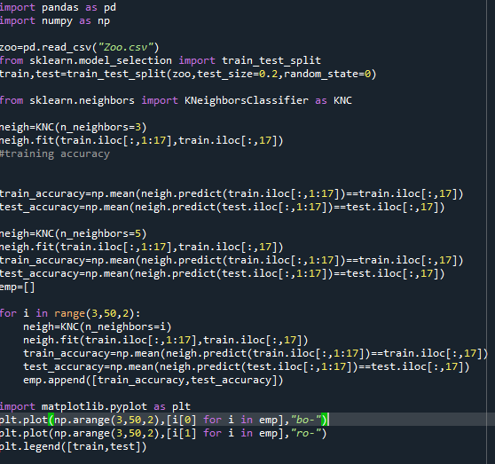

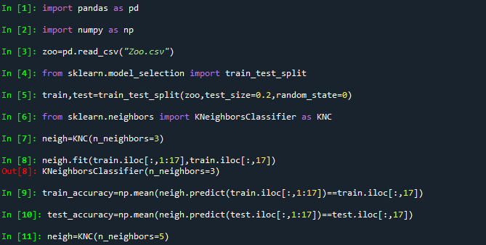

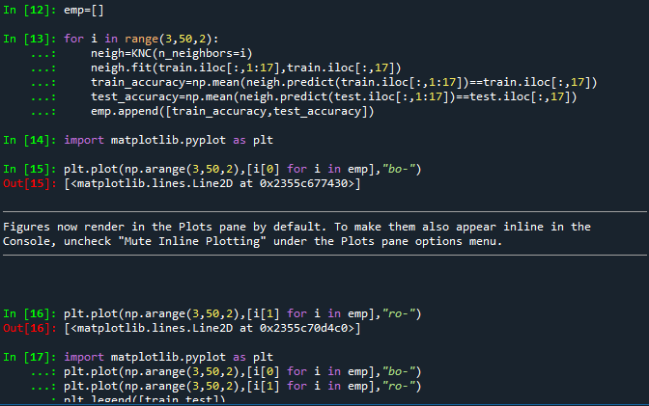

ZOO DATASET:

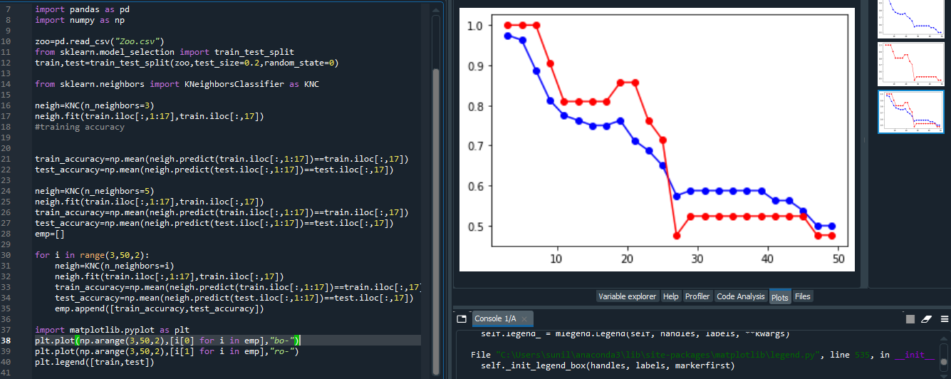

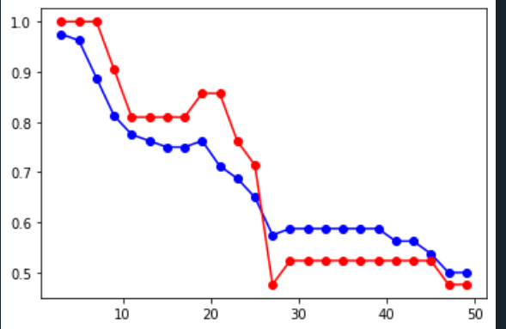

**FOR “GLASS.csv” dataset.**

**Prepare a model for glass classification using KNN**

**Coding:**

# -*- coding: utf-8 -*-

"""

Created on Wed Nov 4 17:50:51 2020

@author: sunil

"""

import pandas as pd

import numpy as np

zoo=pd.read_csv("Zoo.csv")

from sklearn.model_selection import train_test_split

train,test=train_test_split(zoo,test_size=0.2,random_state=0)

from sklearn.neighbors import KNeighborsClassifier as KNC

neigh=KNC(n_neighbors=3)

neigh.fit(train.iloc[:,1:17],train.iloc[:,17])

#training accuracy

train_accuracy=np.mean(neigh.predict(train.iloc[:,1:17])==train.iloc[:,17])

test_accuracy=np.mean(neigh.predict(test.iloc[:,1:17])==test.iloc[:,17])

neigh=KNC(n_neighbors=5)

neigh.fit(train.iloc[:,1:17],train.iloc[:,17])

train_accuracy=np.mean(neigh.predict(train.iloc[:,1:17])==train.iloc[:,17])

test_accuracy=np.mean(neigh.predict(test.iloc[:,1:17])==test.iloc[:,17])

emp=[]

for i in range(3,50,2):

neigh=KNC(n_neighbors=i)

neigh.fit(train.iloc[:,1:17],train.iloc[:,17])

train_accuracy=np.mean(neigh.predict(train.iloc[:,1:17])==train.iloc[:,17])

test_accuracy=np.mean(neigh.predict(test.iloc[:,1:17])==test.iloc[:,17])

emp.append([train_accuracy,test_accuracy])

import matplotlib.pyplot as plt

plt.plot(np.arange(3,50,2),[i[0] for i in emp],"bo-")

plt.plot(np.arange(3,50,2),[i[1] for i in emp],"ro-")

plt.legend([train,test])

